Lab 11 Action potential propagation

Zhuoyang Chen 11/25/2019

**Model**

The pdepe function used here is for parabolic (p) and elliptic (e) form of partial differential equations. The components of the second order differential matter, so before using this function we have to figure out which is the dependent variable, which are the independent and which of the independent variable has the second order differentiation form.

$$A\left(x,t\right)∙\frac{∂^{2}V}{∂x^{2}}+B\left(x,t\right)∙\frac{∂^{2}V}{∂x∂t}+C\left(x,t\right)∙\frac{∂^{2}V}{∂t^{2}}=F(x,t,V,\frac{∂V}{∂x},\frac{∂V}{∂t},⋯)$$

When $B^{2}-4AC>0$, the system is hyperbolic.

When $B^{2}-4AC=0$, the system is parabolic.

When $B^{2}-4AC<0$, the system is elliptic.

In our action potential case:

$$\frac{∂V}{Vt}=D\frac{∂^{2}V}{∂x^{2}}+\frac{1}{C}(g_{Ca}m_{∞}\left(E_{Ca}-V\right)+g_{K}ω\left(E_{K}-V\right)+g_{leak}\left(E_{leak}-V\right))$$

$$\frac{dω}{dt}=\frac{ω_{∞}-ω}{τ_{ω}}$$

There is only one component that has a second partial differential equation, which is the diffusion term, so A = 0, B = 0 and C = 0 in this case, and by definition the system is parabolic.

**Baseline run**

The narrow peaked voltage pulse triggering the system is introduced by setting the first 1 cm of the 30 cm neuron to a positive voltage 20 mV and this positive charge can propagate through the neuron by diffusion.

**if** x**<=**x_on

value **=** **[**V_on**;** 0.004**];**

**else**

value **=** **[-**61.9**;** 0.004**];**

**end**

By running the program, we can plot the figure about how potential changes with position along the neuron and propagation time. Results are shown as below:

Boundary condition is set with

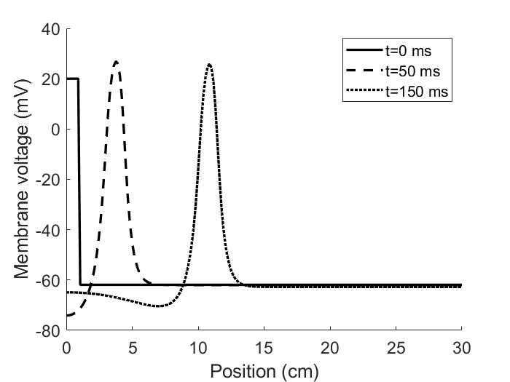

From the above figure, we can see the scheme of how the action potential propagates along the neuron at a specific time. For example, at t = 0 ms, we only have the stimulus at the first 1 cm. At

t = 50 ms, the first 1 cm where the original stimulus is becomes a negative charge due to the repolarization process K+ and other ions fluxing back, and the stimulus triggers a action potential, which then propagates to the position around 4 cm. At t = 150 ms, the action potential propagates to around 11 cm.

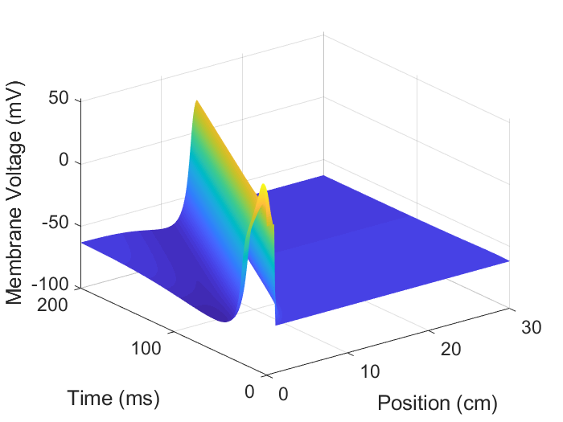

From figure above, we can see that action potential propagates along neuron as time goes by. But the propagation cannot exceed 15 cm and there are no action potentials at all. There is subtle change for potential of position at >15 cm after 100 ms.

**Excitability and propagation**

Changing the initial voltage pulse from 20mV to 40mV and 60mV, plot the time serial potential data of a specific position, i.e. 7.5cm by plot(t,V(:,50)). Results are shown as following.

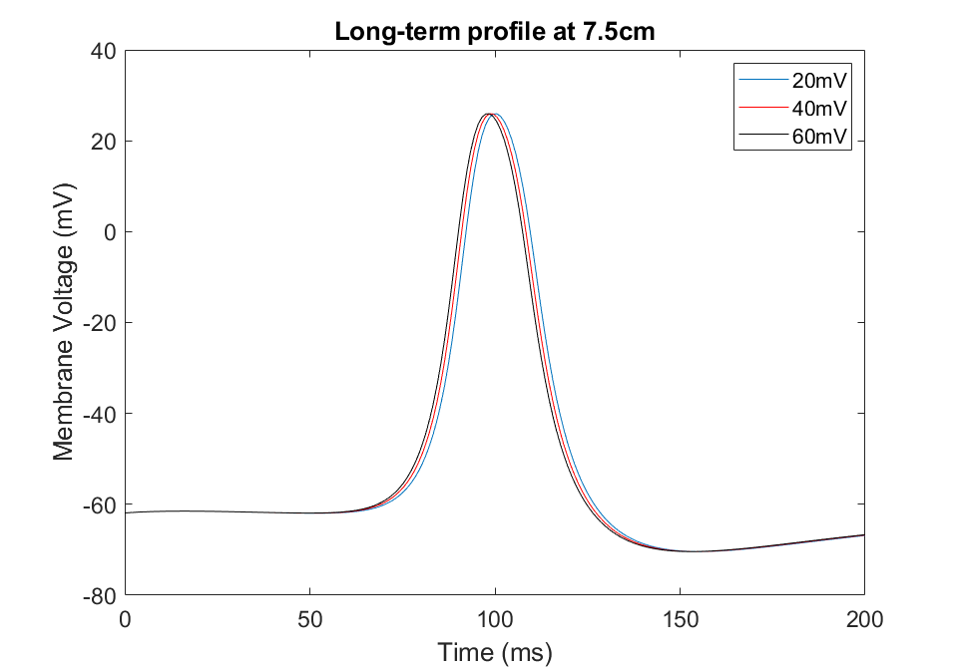

**Action potential propagation along time**

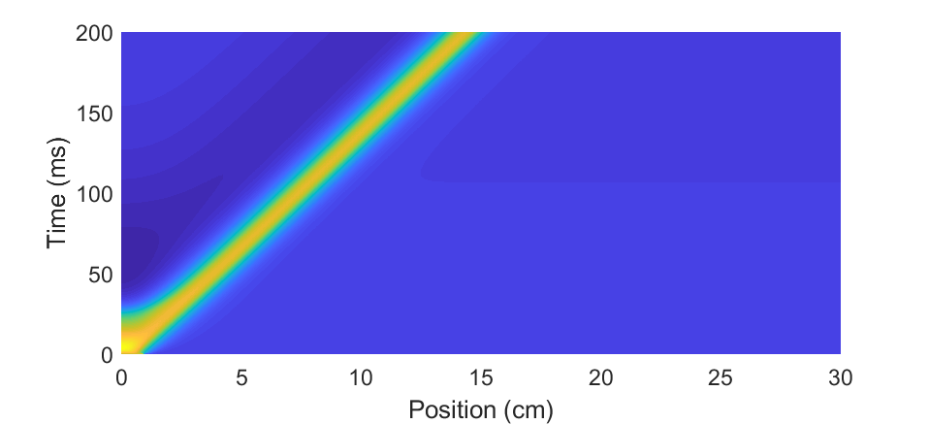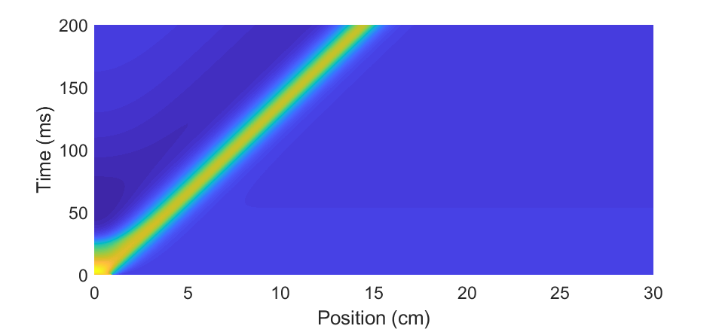

From top to bottom is 20 mV, 40 mV and 60 mV.

There is little bit left shift when increasing stimulus amplitude but the overall profile of action potential is unchanged when looking at the amplitude of the action potential, and speeds of propagation under different stimulus initial condition are almost the same.

To explore the minimal stimulus amplitude to trigger an action potential, change the V_on.

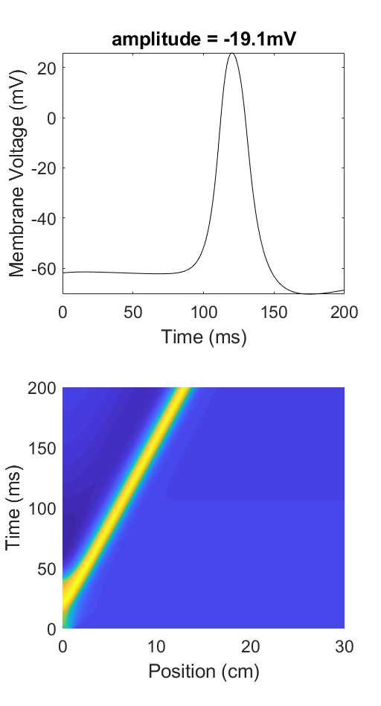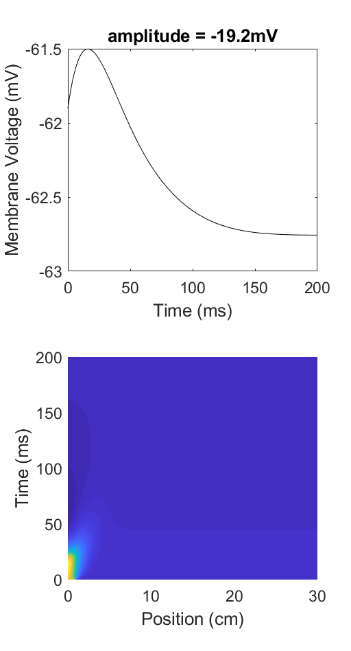

The minimum is around -19.1 mV.

Apply a pulse of value V_on for all position along the table, initial condition is

value = [V_on; 0.004];

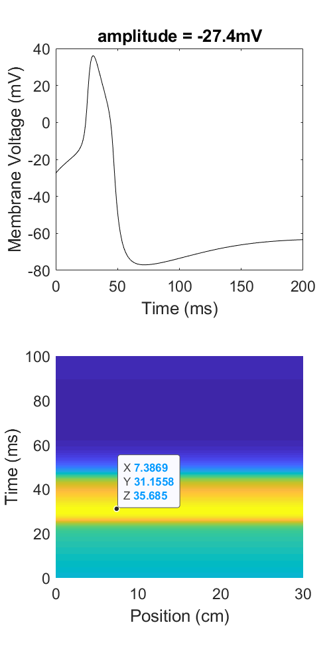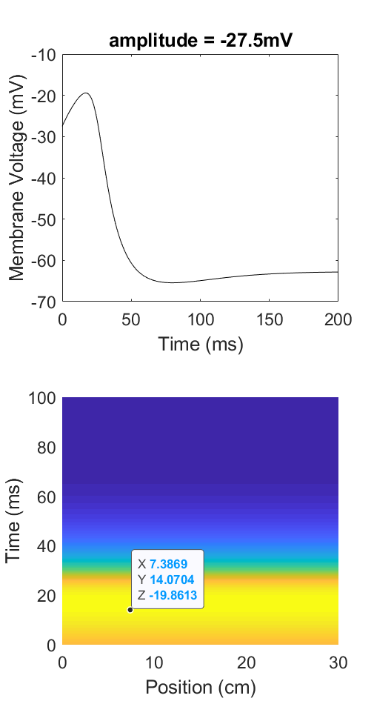

The minimum is around -27.4 mV.

Compared to the un-coupled model, the coupled model needs a larger minimal stimulus of -19.1 mV against -27.4 mV. When applied a pulse to all the grid points, there is no flux between nearby points. As we know, the direction of diffusion flux is opposite to the generated potential, which would set off part of the effect of a stimulus. Thus in coupled model (smaller region), a larger pulse is required to overcome the adverse effect of diffusion.

**Wave speed and conductivity**

As D increasing, the wave speed would increase due to the greater effect of diffusion. To verify the assumption, run the simulation by varying D with increasing values. Results are shown as below.

D = 0.035 D = 0.05

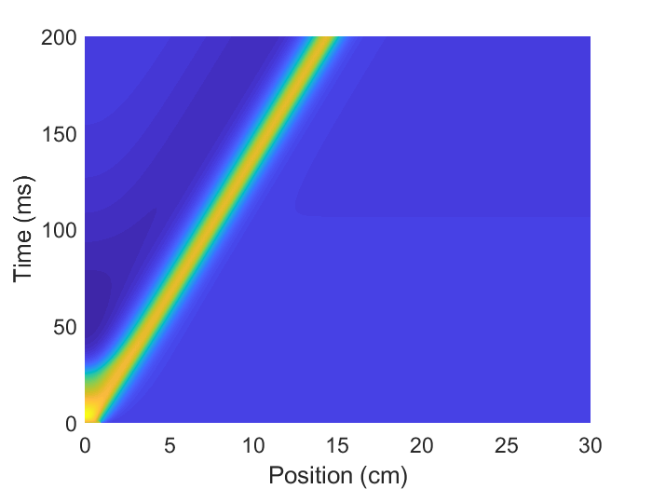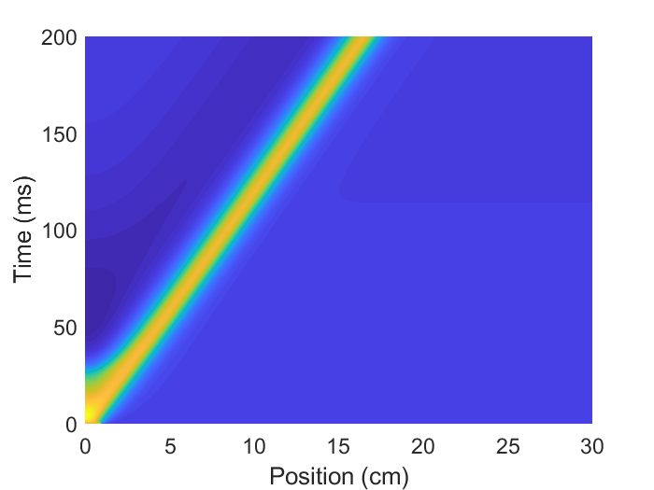

D = 0.1 D = 0.2

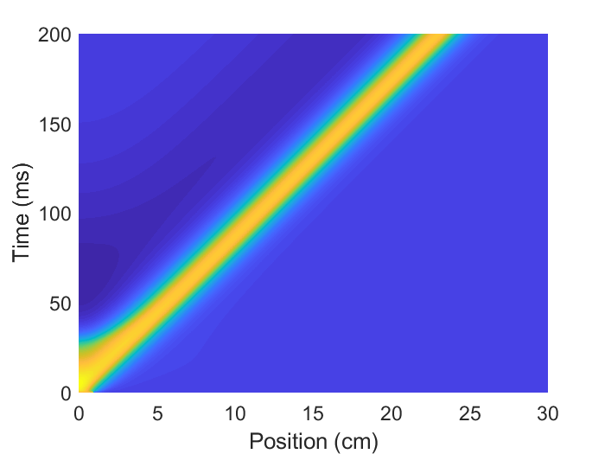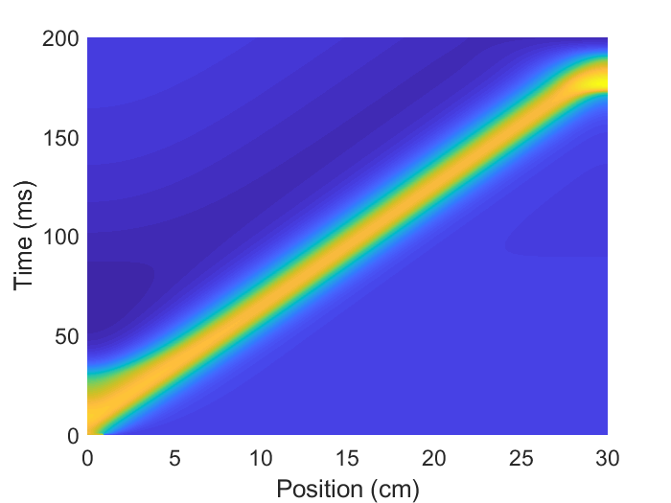

When increasing D from 0.035 to 0.2, we can see the propagation of action potential is going further along the neuron, from less than 15 cm to over the whole length of neuron of 30 cm. The reason is that with greater diffusion coefficient, a greater portion of the previous action potential can propagate to the next position.

**Wave speed and ionic conductance**

I think the direction of Ca flux and K flux is opposite, that when increase gCa, wave speed would increase but when increase gK, wave speed would decrease.

Increasing g_Ca:

g_Ca = 4.4 g_Ca = 5.0

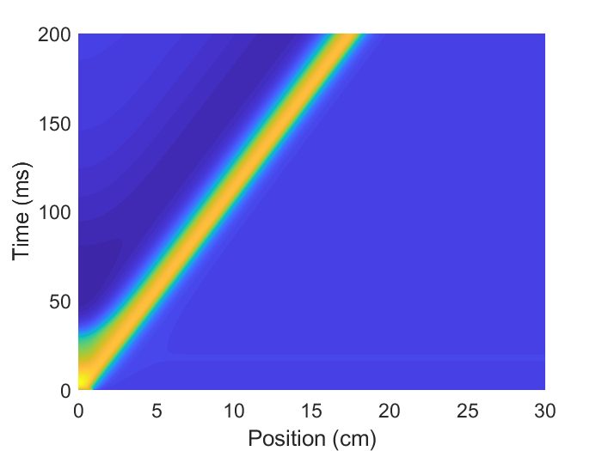

g_Ca = 6.0 g_Ca = 7.5

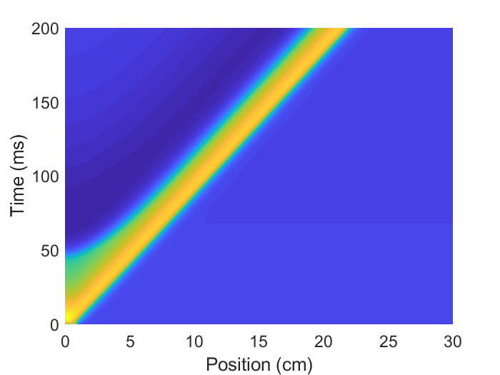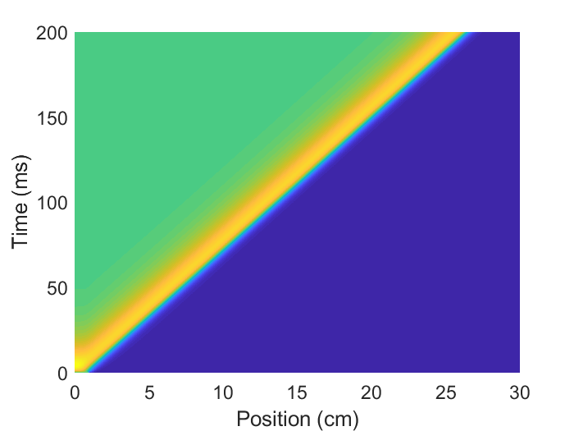

We can see that as g_Ca getting greater, the wave speed is increasing. However, the time required to recover to the rest potential also getting longer and when g_Ca is 7.5, it never returns to rest potential once got triggered.

Increasing g_K:

g_K = 8.0 g_K = 8.5



g_K = 9.0

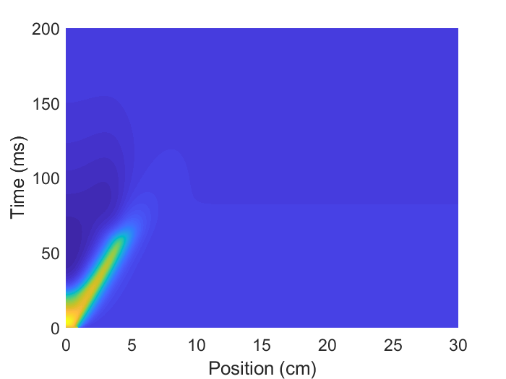

As g_K getting greater, the wave speed is decreasing and a lower action potential is triggered.

That verifies my assumption. I think what determines the profile of the wave is the ration of g_Ca and g_K. When g_Ca is increasing, the relative decreasing g_K is harder to recover the action potential to the rest potential and finally overcome by the great triggering effect in a specific time span. While g_K is getting greater, there is not enough time to trigger an action potential before it recovers.

**Two propagation APs**

Introduce another stimulus at the end of the neuron by setting the first and the last 1 cm of the neuron have initial values with 20 mV potential.

**if** x**<=**x_on **||** x**>=**30**-**x_on

value **=** **[**V_on**;** 0.004**];**

**else**

value **=** **[-**61.9**;** 0.004**];**

**end**

Results shown as below:

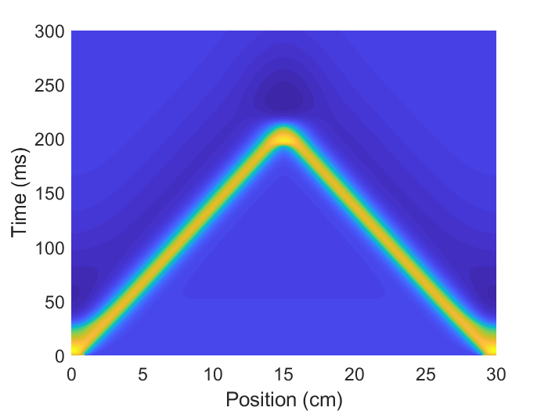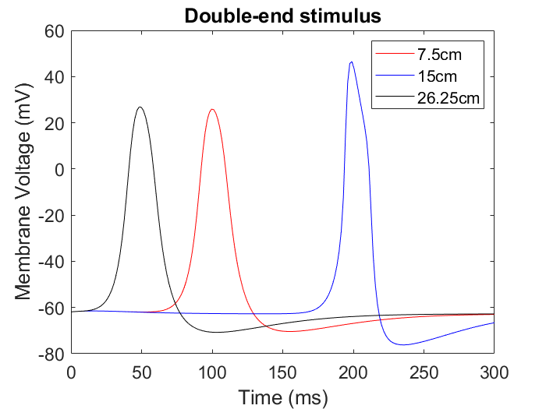

At first each stimulus triggers an action potential and the two waves propagates toward the center of neuron independently with opposite direction. When the two waves reach the center (x = 15cm)

at the same time, they collide and make a greater action potential, with a value near the sum of the two.